|  |
| --- |
| **IT Project** |
| Synoptic Assignment – Section A Version Control |
| Checkpoint 4 – Adding a user for collaboration on a repo using Github.com  By Matthew De Giorgio BAN 6.3A |
|  |

Contents

Preface 1

Step 1 2

Step 2 3

Step 3 4

Step 4 5

Step 5 6

# Preface

Currently, the feature to add a collaborator to the repo does not exist on Gitkraken yet. Instead, the online interface of GitHub will be utilized.

# Step 1

Using your favourite browser, navigate to **GitHub.com** and sign in. You should be presented with the default landing page.

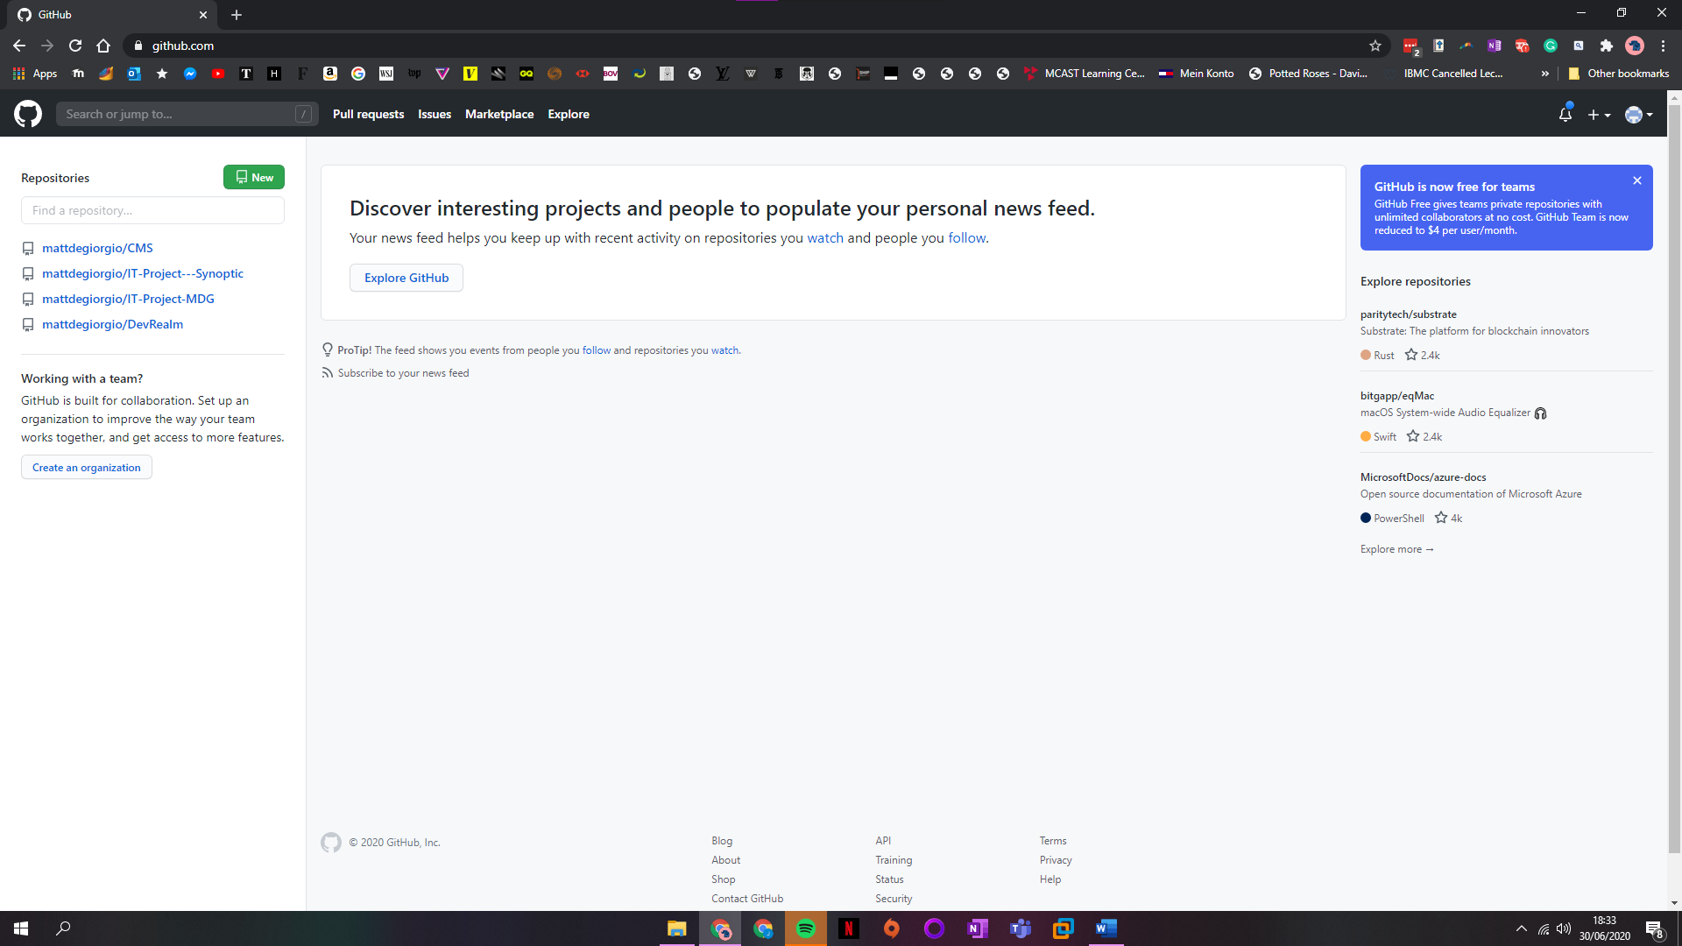

# Step 2

On the left pane, click on the repository that you wish to add a collaborator to.



# Step 3

Once on the main repo page, click on the settings tab found in the top section.

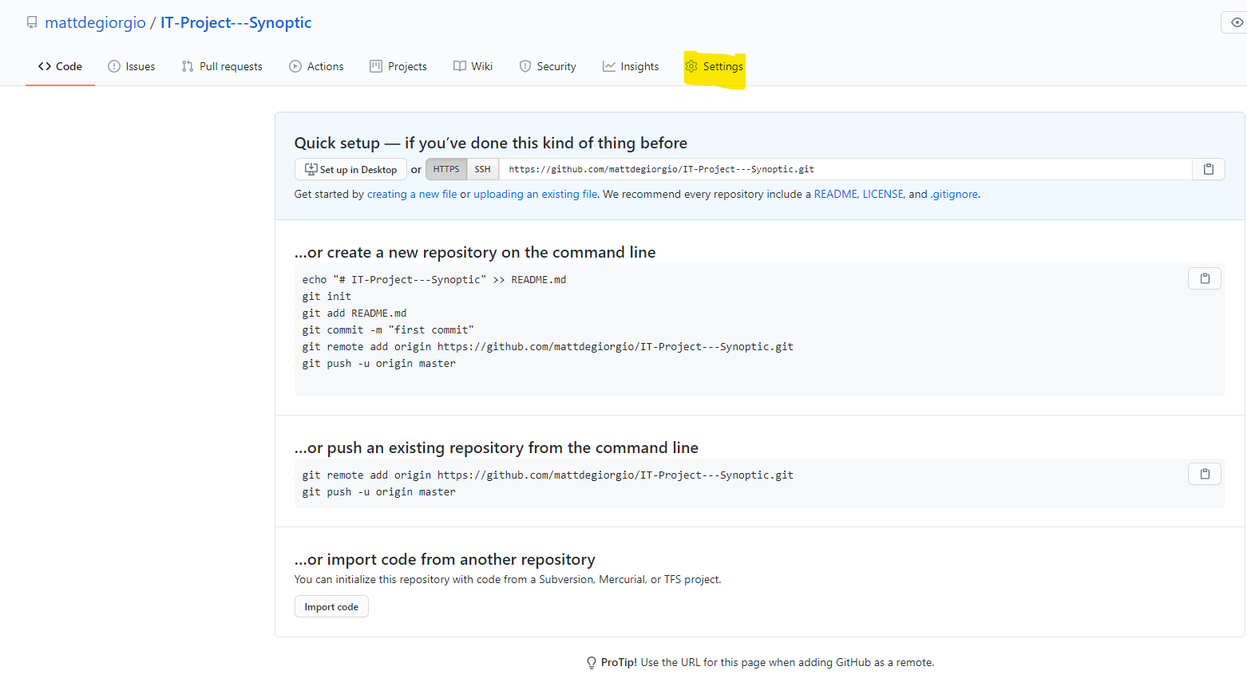

# Step 4

Using the left navigation pane, click on the **Manage Access** tab.

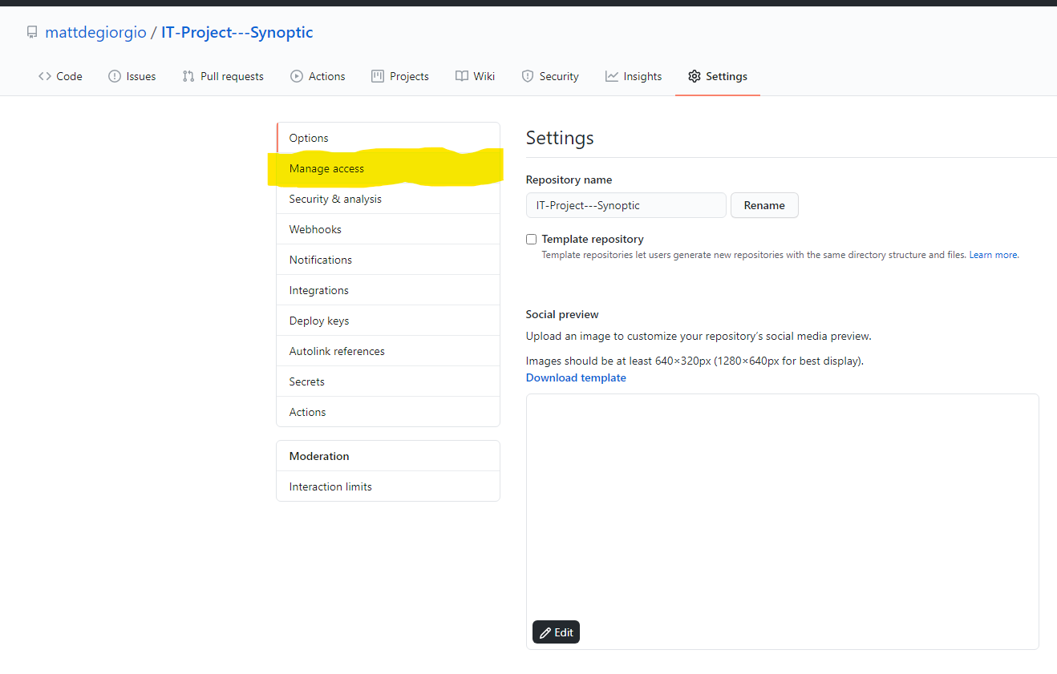

# Step 5

Within the **Manage Access** section, click on the **Invite a Collaborator** button located in the central section and follow the on-screen prompts to add the user using either their GitHub username or an email. Once finished, the user will appear in the **Manage Access** section.

